PSTI Lesson and/or Unit Planning Template Part 1

Teacher’s Name ______________

PART 1a.

Grade and Subject | Instructional Time Required (Minutes) | Enter number of class periods with time (minutes) of each period.
Unit or Lesson Title (Topic)
Anchoring Phenomenon (a) | Phenomenon (a). Please list overarching or “Big Ideas”  Driving Questions. Make a short list of questions that promote deep understanding, higher order thinking, and inquiry and which spark discussion and debate, and raise further questions.  Curriculum Spark(s). What will you do, show or say to pique learner’ interest?
Learning Goals/ Lesson Topics | List main performance expectations and lesson concepts related to grade level and state standards that support student learning goals. For Texas teachers these are the TEKS.
Grade level Performance Expectations (PEs)  and  EVIDENCE of learning. | Use the TEKS as your primary guide for how you state your performance expectation(s).  Note: You may also refer to the grade level NGSS Performance Expectations (PEs) because they have informed the most recent revision of the science TEKS.  --------------------------------------------------------------------------  Please describe the “evidence” that you will look for to determine if your students have mastered content and skills contained in the lesson. List or describe the criteria that you will use to assess if your students have met your performance expectation(s).
PART 1b.

Unpack the components of the Performance Expectations that you choose using the TEKS in the table below.

State standards (Skills) | State standards (Concepts) | Cross-cutting Concepts (CCCs) (e.g., patterns, energy flow, cause and effect, etc.)

PART 1c.

Teacher Preparation
Student Misconceptions  (Potential student ideas that are problematic when engaging in the lesson) | Scientific Terminology  (Vocabulary named once students “figure out” concepts of lesson)
Supporting Information
References  (Links to cite sources of data, images, websites, etc.) | Background Reading/ Viewing  (For teachers and possibly students as well)

Resources/ References (Please cite your resources properly. All websites must be properly cited. Examples of how to cite your sources)

- BBC Four: Ancient Apocalypse: The Maya Collapse, https://www.youtube.com/watch?v=fuFL5ETw6oQ
- Brenner, M., Rosenmeier, M., Hodell, D., & Curtis, J. (2002). PALEOLIMNOLOGY OF THE MAYA LOWLANDS: Long–term perspectives on interactions among climate, environment, and humans. Ancient Mesoamerica, 13(1), 141-157. Retrieved November 6, 2020, from http://www.jstor.org/stable/26308050
- Gill, Richardson (2018). The Great Maya Droughts: Water, Life, and Death, University of New Mexico Press.
- Hodell, D., Curtis, J. & Brenner, M. (1995). Possible role of climate in the collapse of Classic Maya civilization. Nature 375, 391–394. https://doi.org/10.1038/375391a0
- Marx, W., Housnchild, R. and Bornmann, L. (2017). The Role of Climate in the Collapse of the Maya Civilization: A Bibliometric Analysis of the Scientific Discourse, Climate 5(4):88. DOI: 10.3390/cli5040088

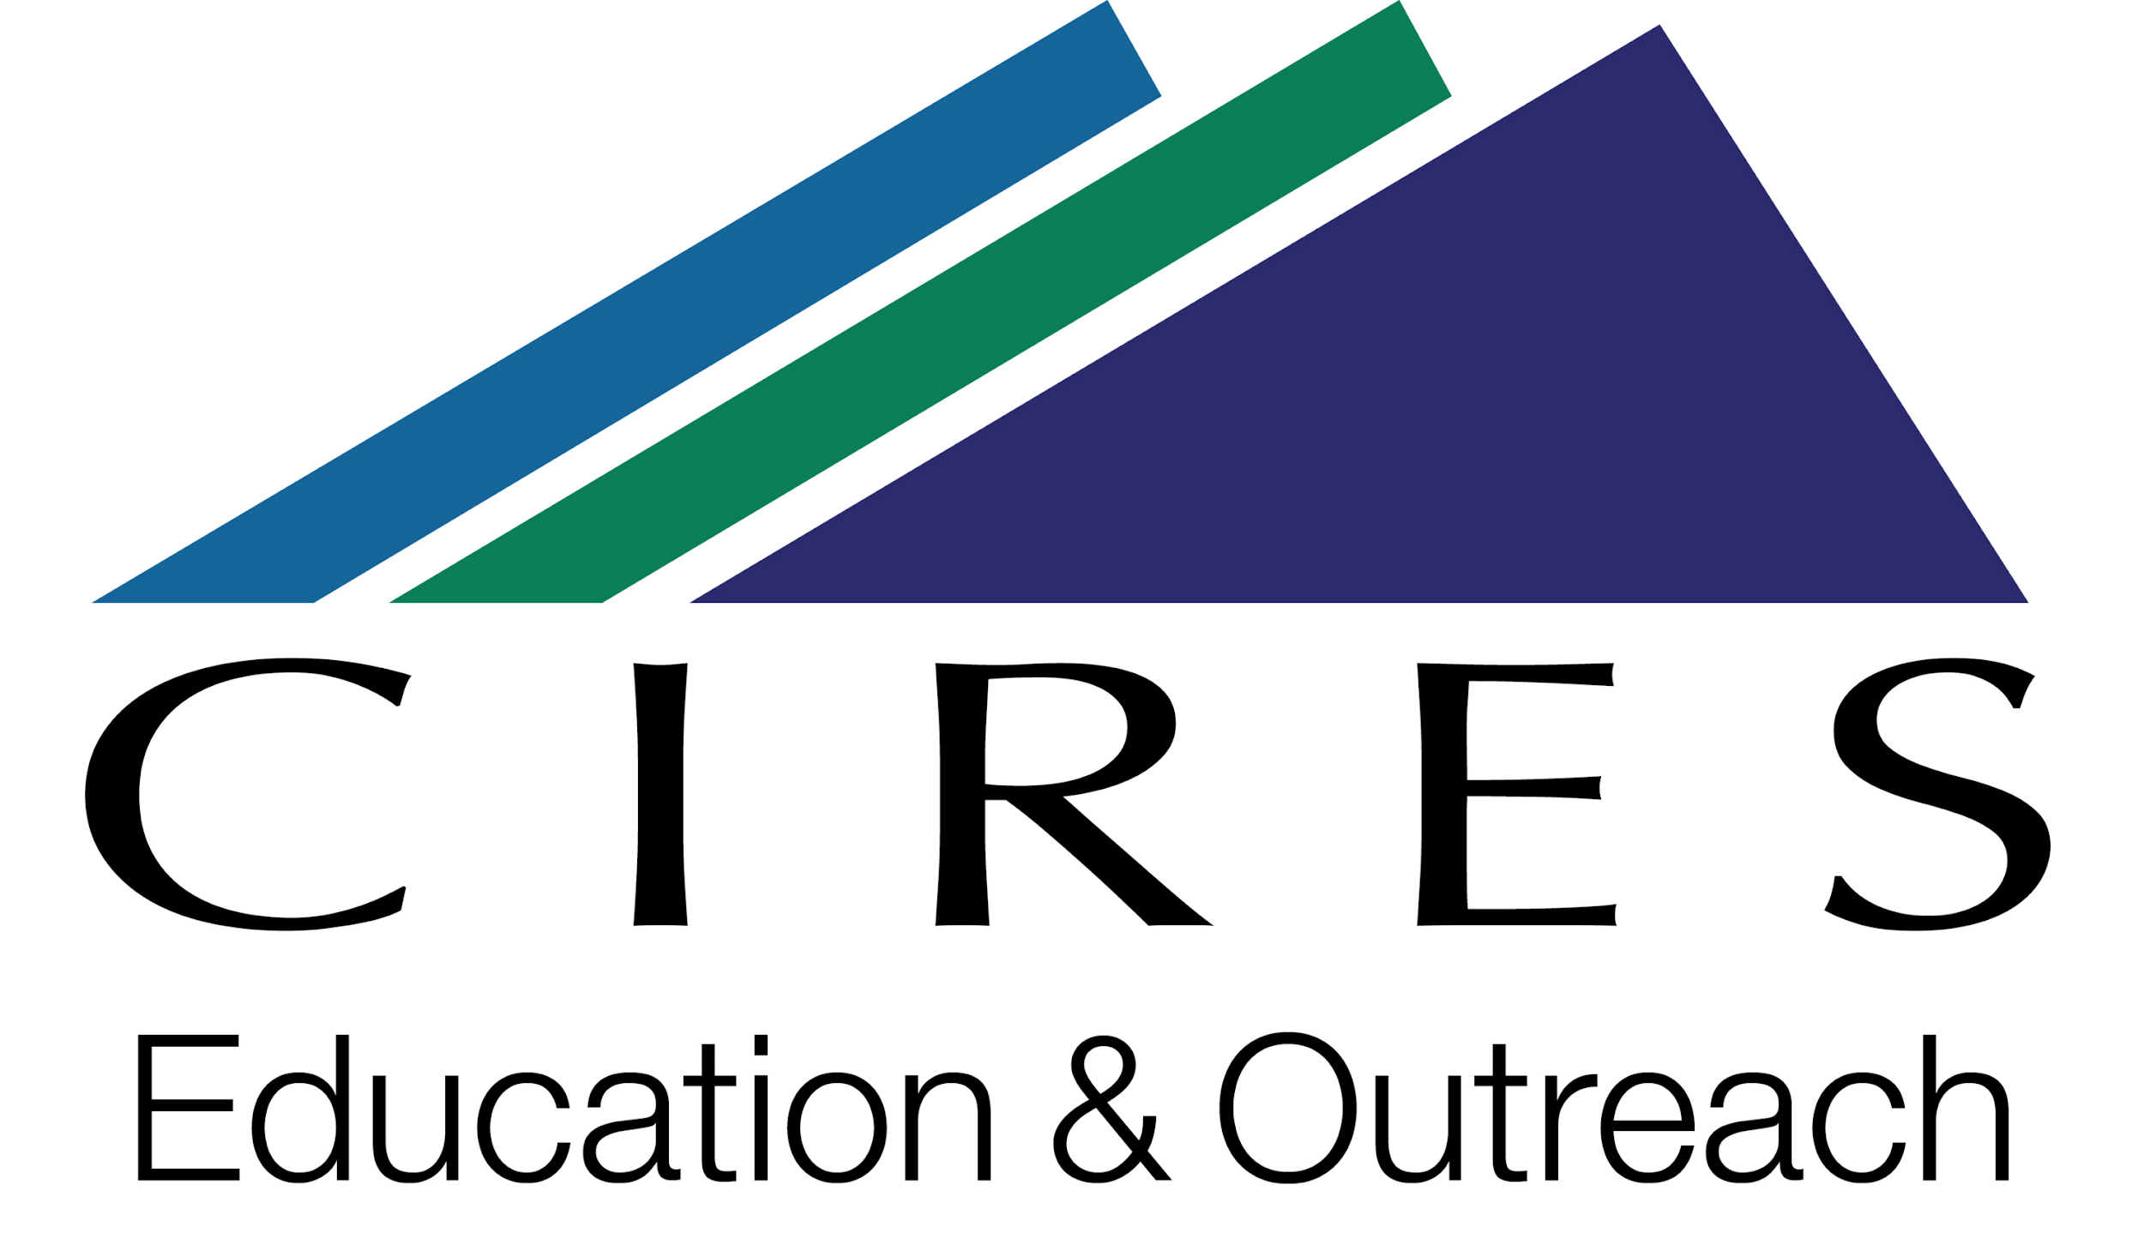

This lesson planning template was adapted for the PGE Hildebrand PSTI project by Katherine Ellins, using materials that were developed by CIRES Education & Outreach at the University of Colorado Boulder. CIRES teaching materials are available at https://cires.colorado.edu/outreach/resources/planning-templates.

The original template is licensed by CIRES under a Creative Commons Attribution 4.0 License http://creativecommons.org/licenses/by/4.0/

RESOURCES FOR TEACHERS

Phenomena

Phenomenon based learning starts from the shared observation of holistic, genuine real-world phenomena in the learning community. The observation is not limited to one single point of view; the phenomena are instead studied holistically from different points of view, crossing the boundaries between subjects naturally and integrating different subjects and themes. As you go through the PSTI, you will see the many ways in which this happens.

See more at http://www.phenomenaleducation.info/phenomenon-based-learning.html

This brief resource about phenomena was developed for educators, and describes how phenomena can be used in NGSS classrooms to drive teaching and learning. As Texas teachers you will be focused on the TEKS. However, this resource may help you in your lesson planning activities. The three-minute video interview below with Brian Reiser introduces phenomena and is especially helpful in describing the value using phenomena in your teaching.

Performance Expectations

Use the TEKS as your primary guide for how you state your performance expectation(s).
You may also refer to the grade level NGSS Performance Expectations (PEs) that support student learning goals for additional guidance since these have been used to inform the revised science TEKS. For the NGSS, the PE color coding reflects its 3-dimensional learning components.

Evidence of Learning

Note: If you need guidance on “evidence” of content and skills mastery you can search the NGSS Evidence Statements. These evidence statements will offer examples of what students should know and be able to do to satisfy an NGSS Performance Expectation (PE). You can follow the examples as you develop your own criteria for the evidence you are looking for after students complete the lessons you develop.

