CARBON STORAGE DESIGN PROJECT: Cranfield Field, Mississippi, USA

Your team is in charge of evaluating the potential for CO₂ storage in the Cranfield field in southwest Mississippi (see location map below) for your company. Based on the team’s research, you know that the original field produced oil, gas condensate, and methane gas between 1944 and 1966. The field was eventually abandoned in 1965.

Your company is looking at the field for the possibility of a carbon storage project. For your preliminary evaluation you have the opportunity for your team of geoscientists and engineers to examine well data (well logs, core) from the field. At the conclusion of your team’s study, you will make a recommendation for either further study of the potential project, or your company’s abandonment of the potential project.

Questions to consider in your team as you assess the potential for this carbon storage project:

- Is there an adequate reservoir in the subsurface to serve as an injection zone for the CCS project? (e.g., type of rock, porosity and permeability, depth to the injection zone)
- Is there an appropriate seal to serve as a confining interval for the CCS project?
- Where are the underground sources of drinking water that need to be protected?
- Are there concerns about the project that dictate a monitoring plan?

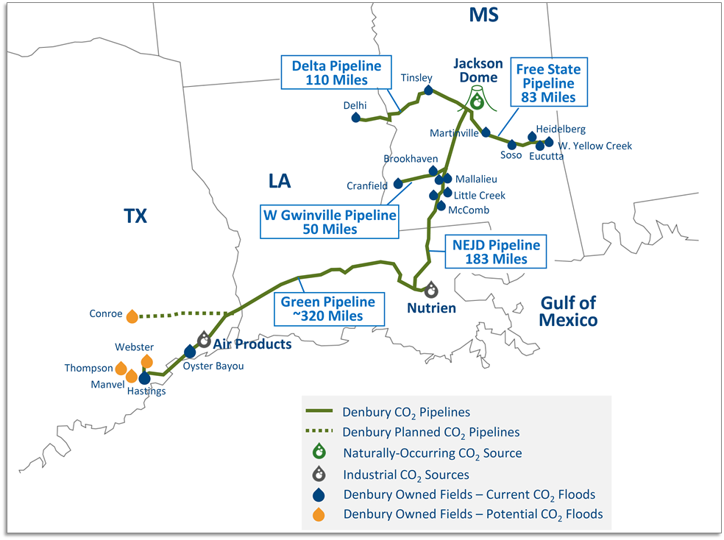
Figure 1. Map showing the location of Cranfield field in southwestern Mississippi. (Denbury Resources)
A. INITIAL GEOLOGICAL RECONNAISSANCE USING A STRATIGRAPHIC COLUMN
As you begin your evaluation, you will familiarize yourself with the geology of the region and the field in general. As you evaluate the project, your team must consider the general rock layers (stratigraphy) of the field, including such aspects as the proximity of the injection interval to Underground Sources of Drinking Water (USDW). The primary confining interval for the injection zone (storage reservoir), as well as redundant protective zones between the injection zone and the USDWs, must be identified. The depth to the injection zone in the field is also an important consideration for your initial study because it will affect the density of the stored CO₂.

A geologist familiar with the history of the field has put together a stratigraphic column for your team summarizing activities and units in the area, as well as the units that are related to a potential storage projects at Cranfield field. As your team investigates aspects of the geology based on the generalized stratigraphic column (shown below) for the area of Cranfield field, Mississippi, answer the questions based on the stratigraphic column. The legend of the figure will be helpful in understanding the stratigraphic column.

Discussion Questions on Stratigraphy (Use Figure 2: Generalized stratigraphic column)
- Previous wells in the area mean more data for your reconnaissance study. Wells are usually a result of previous oil and gas activity. How many oil-producing formations has the geologist noted in the region?
- This column specifically highlights the reconnaissance study for the Cranfield field. What is the name of the injection zone at Cranfield and what is its geologic age (System)?
- What is the depth to the deepest USDW on the stratigraphic column (shown as a confined aquifer on the stratigraphic column)?
- How many confining units are located between the lowest USDW and the injection zone at Cranfield? What different lithologies are represented by these various confining units?
- What is the name of the lowest regional seal that represents the confining unit for CO₂ injection at Cranfield?
- What is the depth to the injection zone based on this stratigraphic column? Why is the depth important to note for a reconnaissance study?

Generalized stratigraphic column

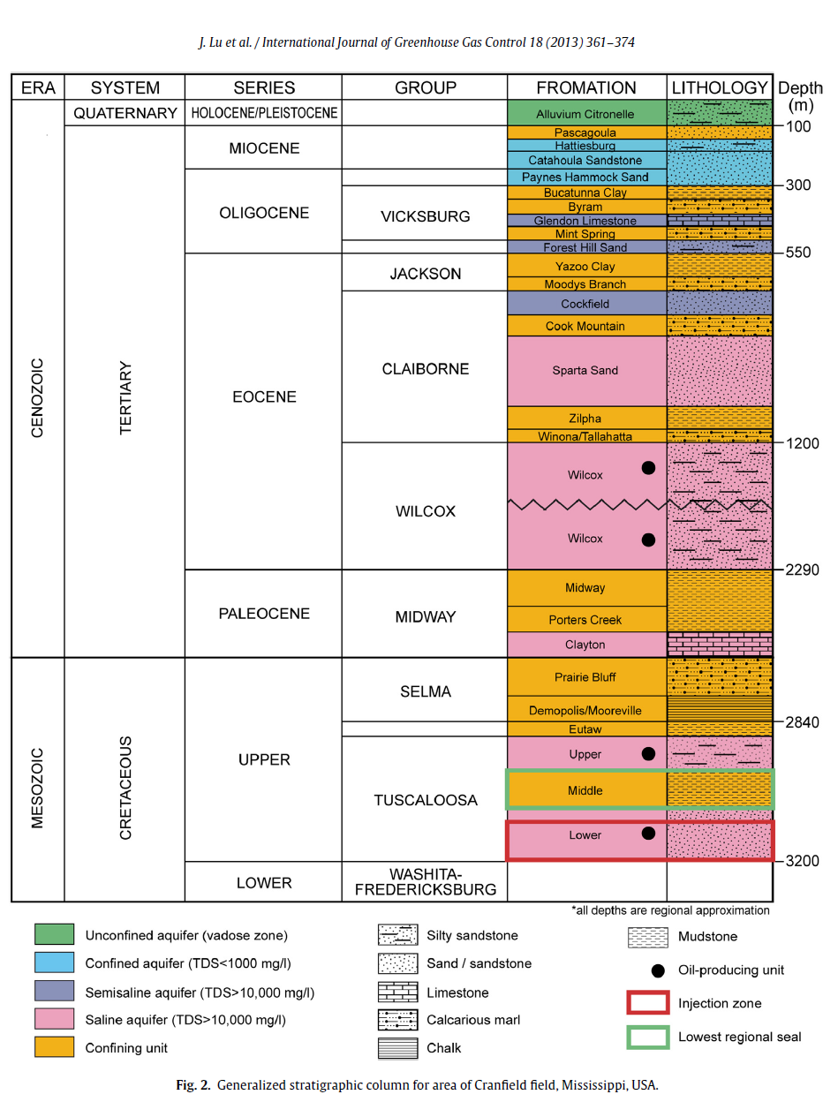
Figure 2. Generalized stratigraphic column for area of Cranfield field, Mississippi, USA. (Lu et al., 2013)
B. WELL-LOG ANALYSIS

Your team has data from six wells in the form of well logs. These have been put together in a cross section display (CROSS SECTION v.1), which you should now request. Note that all of the logs have been ‘hung’ on the same datum (for example, sea level). The depths in the well are noted as the true vertical depth (TVD) from that datum. This display allows you to examine the geometry of the rock formations in the subsurface (e.g., Are they horizontal? Are they folded? Are they inclined? Are they continuous across the area or discontinuous?).

A location map (Figure 3) of the field shows you the location of each of the six wells, and thus the orientation of the cross section (a graphical representation of vertical slices through the earth to help us interpret the geology). The cross section is shown on the map using a black line connecting the wells.

Things to notice about the cross section from this map to get you oriented:
- The cross section starts on the west side of the field at well 44-2.
- The cross section crosses a fault (the wide grey line) between well 29-12 and well 27-5.
- The cross section turns southeast where the last three wells, 31F-1, 31F-2 and 31F-3 are all very close at the end of the cross section.

Location Map
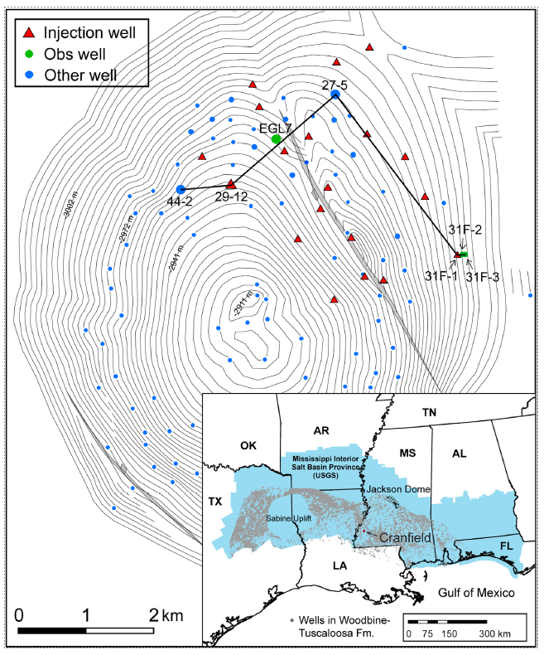
Figure 3. Location map showing the six wells used in the cross section (black line) for this assessment. Wider grey lines indicate faults in the field. North is at the top of the map.
You will be analyzing the Gamma Ray track on the logs. It is important to note that high gamma ray values typically correspond to shales (the clays in the shales are more radioactive), and low gamma ray values typically correspond to sands (the sands typically do not have many clays and are less radioactive).

Your team now interprets the well logs from CROSS SECTION v.1. As a team, answer the following questions to help in the interpretation.

Discussion Questions to Begin Well-Log Interpretation

- Look at the two well-log tracks (squiggly lines). Identify which track is the Gamma Ray (GR) track. This is the track you will focus on for your reconnaissance study. The units are referred to as gamma ray API units (GAPI). What is the total range of the track displayed for each core (minimum and maximum value)?

- Excursions of the track to the left should be interpreted as: shale or sand ? (circle one)
- Excursions of the track to the right should be interpreted as: shale or sand ? (circle one)
- Look at the first well on the left side of the cross section (well 44-2). At what depth interval in the well do you see approximately 15m of continuous sand?
The normal procedure when interpreting these logs is to highlight the sandy intervals using yellow.
******************************** FAST FORWARD *******************************

Using the observations similar to those noted above, your team has now made a preliminary interpretation of five of the wells as shown in CROSS SECTION v.2, which you should now request. Your team has highlighted the sandy intervals based on the well logs in five of the six wells.

Find that sandy interval you earlier identified in well 44-2. You should see that the gamma ray value to the left of the mid-line value is highlighted in yellow.
Your team will now follow a similar procedure to finish up with the interpretation of CROSS SECTION v.2 by interpreting the sands in the 31F-2 well. You will need a yellow pencil.

Guided Instruction for Well-Log Interpretation (CROSS SECTION v.2)

- Look at the display of CROSS SECTION v.2. You can see where your team has interpreted the gamma ray log for five of the wells and has posted the interpretation of sand in yellow on those logs. Using a yellow pencil, your team should now interpret the sands in the 31F-2 well log in a similar fashion to complete the interpretation of all wells in the cross section.
C. CORE ANALYSIS AND INTEGRATION

Your team is aware that core has been collected in the 31F-2 well (note the legend on the CROSS SECTION you are working with). Study of this core would be of interest to add confidence to your team’s log interpretation.
Remember that logs are interpreted from a series of instruments lowered into the well that sense various properties of the surrounding rock and / or contained fluids. With core data you get an actual glimpse at the rock buried thousands of meters deep in the earth when it is brought to the surface. This glimpse gives added confidence to your well-log interpretation – for example, you can verify that what you interpreted as a sand on a well log actually is a sand in the core. Your team now gathers at one of the tables displaying the SYNTHETIC CORE to look at the (synthetic) cored interval from the 31F-2 well and compare it to a well log display. Bring your CROSS SECTION v.2 with your sand interpretation for 31F-2 to the table where your team’s core is displayed.
Below are some questions your team uses to better assess the confidence in their interpretation as you look at the synthetic core and the well log.

Discussion Questions for Core Calibration of Gamma Ray Well Log in Well 31F-2 (Synthetic Core and Expanded Individual Well Log 31F-2)
- Notice the gamma ray log for well 31F-2 has been displayed to match the scale of the synthetic core and enable you to easily confirm your well-log interpretation (sand vs. shale). Take some time for your team to compare the synthetic core and your well-log interpretation of sand, using the expanded well log as a linking mechanism between scales. Describe your team’s confidence in your well-log interpretation now that you have been able to ground-truth the well-log interpretation with core.

- Note the geological interpretation of the core by the geologist who previously examined it. The interpretations for three boundaries between four rock formations (intervals) have been labelled on the synthetic core (they match the units in the stratigraphic column shown in Figure 2). Transfer those three boundaries with a mark at each of the appropriate depths on Well Log 31F-2 on CROSS SECTION v.2. What is the approximate thickness of the injection unit and the confining interval?

  - Middle Tuscaloosa (confining interval – this will confine/seal the CO₂)
thickness =
  - Lower Tuscaloosa (potential CO₂ injection zone – this will contain the CO₂)
thickness =

- Taking into account any adjustments your team may have made to your well-log interpretation based on integrating core into your well-log analysis, your team now redisplays your cross section with a final sand vs. shale interpretation as shown in CROSS SECTION v.3, which you should now request. You should now return to your team table.

D. CROSS SECTION ANALYSIS

Your team will now correlate between the wells on CROSS SECTION v.3. The following instructions will help your team in its interpretation.

Guiding Instructions for Cross-section Interpretation

- Your team will now use CROSS SECTION v.3 and the geological information from the synthetic core, to interpret the four rock formation divisions (three boundaries) across the cross section. You will need purple, green, and red pencils to mark the three boundaries:
  - Upper Tuscaloosa/Middle Tuscaloosa boundary (purple pencil)
  - Middle Tuscaloosa/Lower Tuscaloosa boundary (green pencil)
  - Lower Tuscaloosa/Washita-Fredericksburg boundary (red pencil)
- Your team will start with the Lower Tuscaloosa/Washita-Fredericksburg boundary on 31F-2. Mark the depth of the boundary (determined from the synthetic core) on that specific well panel on CROSS SECTION v.3. [The convention is to mark a straight line at the depth of choice across the individual well panel, from the left side to the right side of the narrow panel strip, including the depth track.] ***Hint: The expanded well log next to the core actually has these lines drawn. Mark this same type of line on the 31F-2 panel on your CROSS SECTION v.3.
- What is the unique log pattern that sits just above the Lower Tuscaloosa/Washita-Fredericksburg boundary (the line you just marked) on 31F-2? Use pattern recognition to interpret that same lowermost boundary line at the appropriate depth for each of those five other well panels. You should now have a series of six panel-width, horizontal lines: one for each of the six wells.

- Next connect up those horizontal lines (those connector lines between well panels will most likely not be horizontal). Your team has now correlated the Lower Tuscaloosa/Washita-Fredericksburg boundary across the cross section.

- Repeat steps #2-4 for the other two boundaries:
  - Upper Tuscaloosa/Middle Tuscaloosa boundary
  - Middle Tuscaloosa/Lower Tuscaloosa boundary

[You will now have three boundary lines correlated across the cross section.]

Congratulations to your team: You have successfully correlated the well logs for your reconnaissance project.

E. SELECTION OF INJECTION ZONE IN THE LOWER TUSCALOOSA

In addition to defining the Lower Tuscaloosa (the potential injection interval) for the project, you complete further study and find two distinct sand zones recognized on core and well logs within the injection interval. You have included the boundary between these two sand zones correlated across all six wells on your next updated CROSS SECTION v.4, which you should now request.

Your team investigates the specific sand interval for injection based on CROSS SECTION v.4.

- Look at the injection interval (Lower Tuscaloosa) in CROSS SECTION v.4. You have interpreted two separate sandy intervals: Pilot, A-C Sands at the top of the interval, and Sand D-E at the base of the interval (separated by a dashed line on the cross section). You are looking to store as much CO₂ as possible when it is injected into the selected interval via an injection well. Based on this cross section, do you have a preference to recommend one sand interval over the other for this CO₂ injection program? Which one and why?

F. MONITORING PLAN

A geophysicist on your team has determined from seismic data that there are several faults in the area (Figure 3), and that the one in the northeast part of the field penetrates the injection zone and extends approximately 300 m above the top of the injection zone. You need to determine the potential monitoring plan for the storage project that might be warranted from your analysis.

Your team discusses a monitoring plan
- Do you have concerns about the integrity of the project? Your geophysicist noted that a fault appears to penetrate the confining interval (Figure 3). Why might this be a problem?

- Based on historic data acquired by your team, you verify that during the period of production of oil and gas in the field (pre-1965), no transmission of fluids occurred across this feature. Based on this information, what might you conclude about the risk presented here?

- What type of instrument could you place in a monitoring well at the base of the Upper Tuscaloosa interval (right above the top of the confining interval) to address this risk? How would you describe this monitoring plan (what signal will you look for to indicate the project has been compromised) to the regulatory agency with oversite responsibility?

***Special Feature for our Workshop***
CORE ANALYSIS OF CRANFIELD FIELD UNIT 31F-2 (warehoused at Bureau of Economic Geology, UT Austin)
We will now go to the core lab in the GLT Bldg to view the actual core from Cranfield field

***Further Extensions***
MAKE YOUR RECOMMENDATION
Now that your team has completed their preliminary study, put together a presentation or report with your recommendation. Did your team find that the project warrants further investigation as a potential carbon storage project? Or, did your team find too many problems and recommend abandonment of this location and continued search elsewhere for a storage project? Justify your decision using your analysis above and any figures included in your reconnaissance work.

***Synthetic Core Supplies***
United States Plastic Corp. usplastic.com
Plastic tubing: 1-1/4" OD x 1" ID Clear Extruded Acrylic Tubing Item 44032
End caps: Red Vinyl Cap - 1-1/4" Cap ID x 1" Inside Length Item 41268
Hobby Lobby hobbylobby.com
Casting resin: Amazing Casting Resin Kit SKU: 698308
Various sands and pebbles
Home Depot homedepot.com
Various sands and pebbles in the landscaping department
Note: use resin quite frequently as sands compact in the core. Assume that everything between resin layers may eventually ‘mix’ due to compaction.
Recommendation: You may wish to make just a few short sections of core for well 31F-2 to use in your classroom. Shorter segments (up to .3m long will be easier to create). You could simulate the four actual cores we show you in the core lab, as you will have photos of them. You could then have your own short synthetic cores, matched with photos of the actual core.

***Well Logs and Cross Section***
Well log and cross section v.1-4 files will be made available to you.
The large poster of the cross section will also be made available to you.

