the Houston Museum of natural science
Wiess Energy Hall
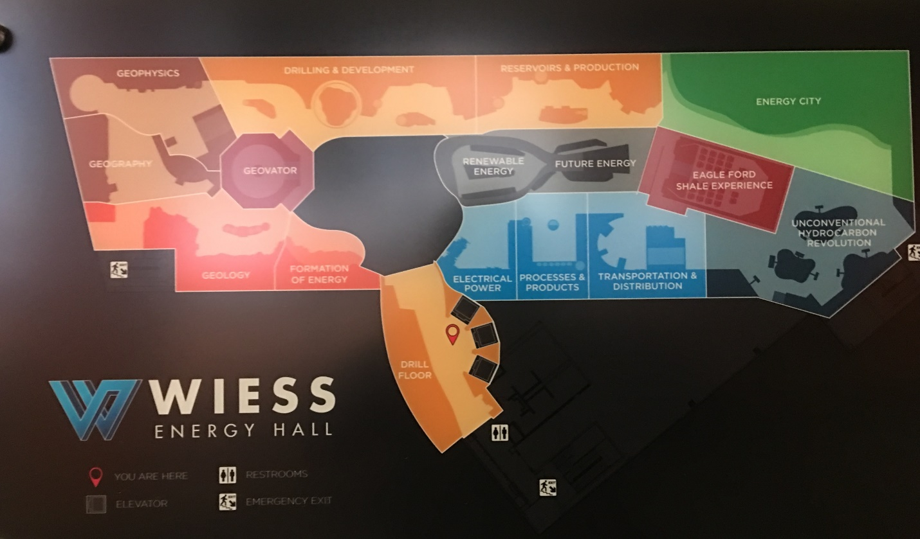
There are a variety of displays throughout the exhibit floor that have to do with energy. For oil and gas, there are displays on upstream, midstream and downstream. Please work your way through the questions below, and the above map can help you navigate.
When you are done, you can hopefully check out the geology/fossil exhibits downstairs!
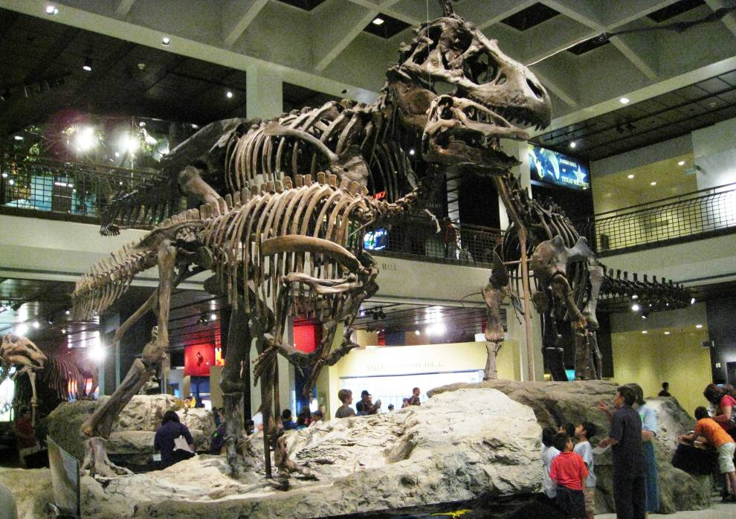

DRILL FLOOR (by the elevator)
FAR OUT (IN THE GULF OF MEXICO)
Today’s offshore drilling platforms represent the intersection of cutting-edge equipment, technical ingenuity, and the mind-boggling industrial capacity wielded by the energy industry. Automated drilling equipment that you see here in this display, makes today’s drilling safer, faster and more precise than ever before.
Watch the automated equipment displayed before you. Name the major pieces of equipment and briefly describe their purpose.
Equipment name | Purpose

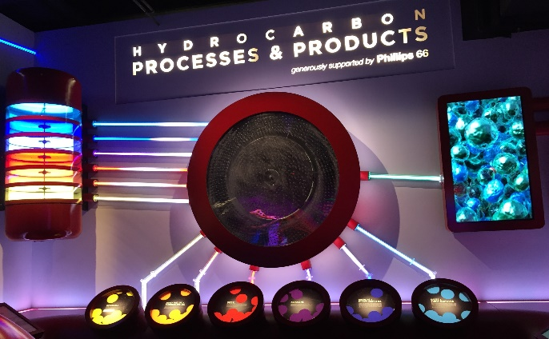
HYDROCARBON PROCESSES AND PRODUCTS
There are six “products” listed in this section. List and describe them.

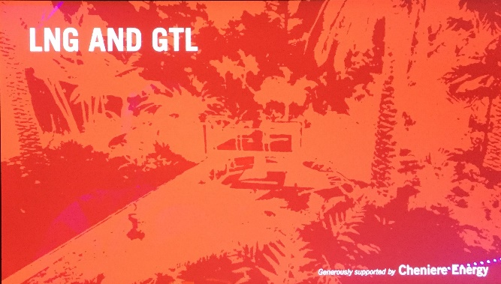
LNG and GTL
Define these two terms. Who is Cheniere Energy (you may need to look this up on your phone)?

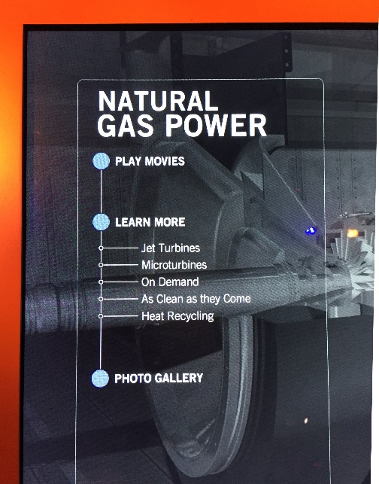
ELECTRIC POWER GENERATION
What do they mean by “As Clean as They Come”?

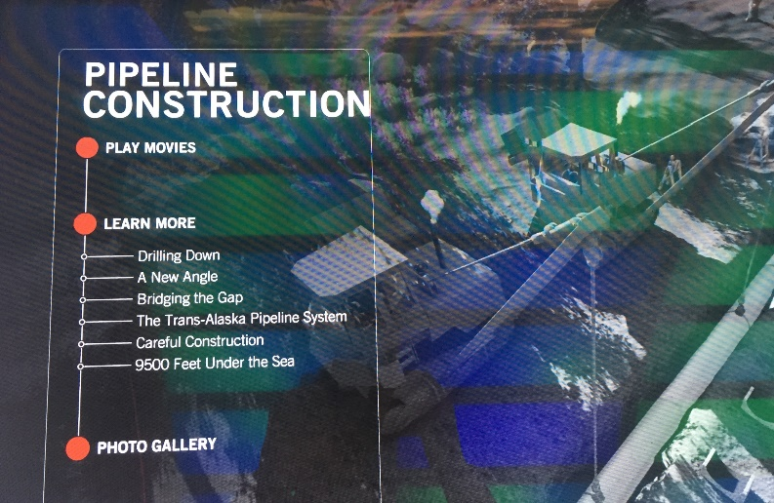
TRANSPORTATION AND DISTRIBUTION
What is the length and capacity of the Trans-Alaska Pipeline System?

DRILLING & DEVELOPMENT
DRILLING OPERATIONS and EXTREME DRILLING
Discuss the difference between a semi-submersible rig, a jack-up rig and a drillship. What are the differences in applications?

- Semi-submersible

- Jack-up

- Drillship

View the display on mud motors.
- What are the components of the system?

- How do you use the same bent housing/assembly to both drill straight and to change direction?

Look at the animation of Drilling with Mud. List and explain the three roles of mud in the drilling process.

GEOPHYSICS
EXPLORATION TOOLBOX (THE GEOPHYSICAL DATA REVOLUTION)
Go inside the Exploration Toolbox and answer the following questions:
Why do we acquire well log data?

FROM MILES TO INCHES PANEL (left of Geophysics of Hydrocarbons)
What different kinds of studies lead to drilling a well? What different kinds of equipment are used?

GEOPHYSICS OF HYDROCARBONS
Look at the diorama of the marine seismic survey. What role does each play? (Try firing the airgun.)
- Airgun
- Hydrophone

Look at the Geophone Seeing with Sound panel. How is collection of seismic data on land different than at sea?

GEOLOGY
TRAPPING STRUCTURES & MIGRATION OF HYDROCARBONS
List four different types of traps.

MIGRATION
Explain how oil and gas migrate from a source rock into a reservoir rock.

How does plate tectonics impact where oil and gas are found?

UNCONVENTIONAL HYDROCARBON REVOLUTION
Describe two interesting highlights from this section.

FUTURE ENERGY
Describe two interesting highlights from this section.

