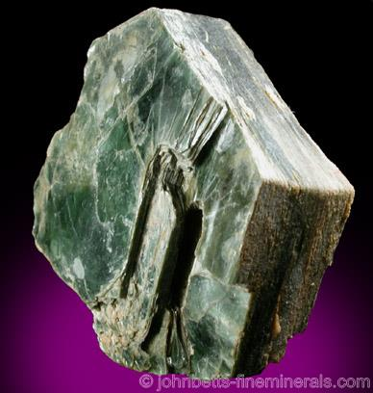
Chlorite and Diagenesis at Cranfield field, Mississippi
Formula: (Mg, Fe)₃(Si, Al)₄O₁₀(OH)₂(Mg, Fe)₃(OH)₆
The name chlorite is from the Greek chloros, meaning “green”, in reference to its color.
(image: https://www.minerals.net/mineral/chlorite.aspx)
Grain-coating chlorite can help sandstone reservoir quality because it inhibits quartz cementation in deeply buried sandstones. Grain coats are up to about 10 μm thick and typically the same thickness on all grain surfaces; they result from rapid indiscriminate nucleation at high levels of chlorite supersaturation in the pore waters and then growth of appropriately oriented nuclei as ultra-thin, roughly equant crystals. (Worden et al., 2020)
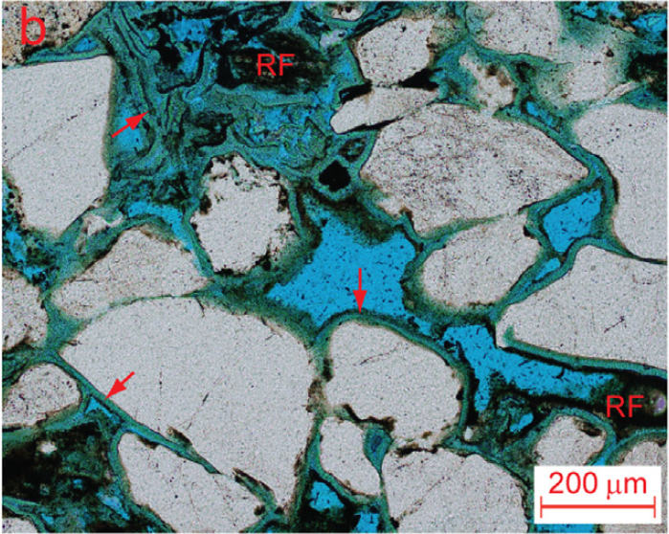
Thin section micrograph of the injection zone Sand D-E at Cranfield. Chlorite (green) occurs as thick coatings (arrows) around grains during earlier diagenesis, preventing quartz cementation during later diagenesis. This preserves porosity (shown by blue epoxy in the slide), rather than filling the pore spaces with diagenetic quartz. (Lu et al., 2013)

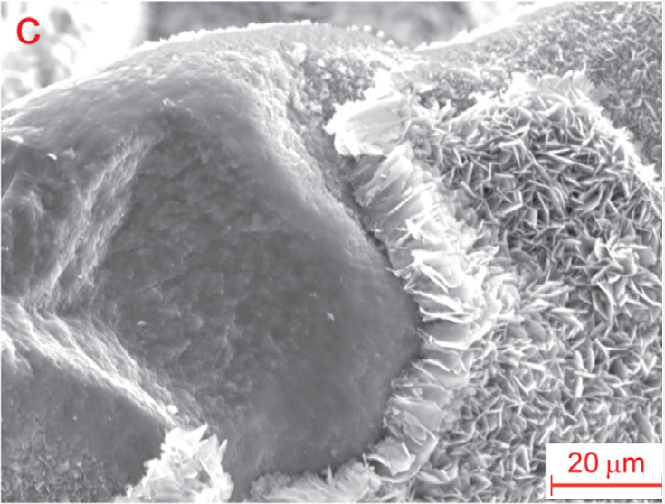

Scanning electron micrograph of chlorite coatings (right) surrounding a quartz grain (left), showing small platy crystals of chlorite oriented perpendicular to quartz grain surfaces. (Lu et al., 2013)

