PSTI Lesson and/or Unit Planning Template Part 2

Teacher’s Name Kathy

Detailed Lesson Planning Template (5-E Model)

Complete each of the 5E Instructional Model section(s). Each will correspond to a partial or complete lesson in your plan. Note: You do not need to use all 5-Es in a single class period. You could use two or three class periods for a single lesson. Or you could combine a series of mini lessons into a longer unit.

Engage: Interest in a concept is generated and students’ current understanding is assessed.
ACTIVATE interest: Introduce curriculum spark/ anchoring phenomenon and driving question.
- Creates interest and Creates equity in the classroom  - Engages students in the concepts through a short activity or relevant discussion  - Connects students’ past and present experiences  - generates curiosity | - Uncovers students’ current knowledge and misconceptions  - Initiates students’ investigation into the curriculum spark/ anchoring phenomenon based on an observation, problem, or question “puzzle through the problems”
Curriculum Spark / Phenomenon-based activity/ event/ video, etc. that drives the Essential (Driving) Questions (questions students are likely to ask about the lesson topic).

I will show students the 12-minute You Tube Video, Deepwater Horizon Blowout Animation, available in Energy Excursions, Macondo Well Case Study, What Went Wrong?

List some Driving Questions. These are authentic and student-focused and relate to investigating the PEs/standards and phenomenon.

- What happened to cause the Deepwater Horizon Blowout?
- What were some of the consequences?
- What are hydrocarbons? How and where do they form?
- What is a well?
- What are the geologic factors that must be considered to safely construct a well?

Lesson Resources Aligned with Standards. Please include titles, source and hyperlinks.

Earth and Space Science (12.B, 12.D)
(12) Solid Earth. The student knows that Earth contains energy… resources and that use of these resources impacts Earth's subsystems. The student is expected to:
(B) describe the formation of fossil fuels, including petroleum...
(D) analyze the economics of resources from discovery to disposal, including technological advances, resource type, concentration, and location, … and environmental costs.
Energy Excursions, In Pursuit of a Safe Well, available at
https://courses.energyexcursions.com/courses/in-pursuit-of-the-safe-well/lessons/macondo-well-case-study/topic/basics-of-the-macondo-prospect/
Lesson Activities: Describe what you will do (experiment, demonstration, video, visualization, Virtual Field Experience (VFE), reading, etc.). The activities must be coherently sequenced to help build understanding of the TEKS). Please provide details of the activity/ procedure, including timing, teacher guidance, student prompts, strategies for discussions and differentiation, etc. Remember, you your teaching time is limited!

- The class will watch together the Deepwater Horizon Blowout Animation video. The video examines the multiple failures that led to the Deepwater Horizon Blowout. It describes how the blowout preventer that was intended to shut off the flow of high-pressure oil and gas from the Macondo well in the Gulf of Mexico during the disaster on the Deepwater Horizon drilling rig on April 20, 2010, failed to seal the well because drill pipe buckled for reasons the offshore drilling industry remains largely unaware of.
- Q&A/ Whole-class discussion
- Formative assessment: Exit Ticket
- Online In class Assignment (self-paced), Energy Excursions, In Pursuit of a Safe Well, What is a Well? (4)
- Teacher provides a summary PPT of material presented in
Geologic Considerations Before Drilling a Well (7)
Engineering Considerations Before Drilling a Well (6)
Formative Assessment: Describe in detail, the assessment that you will carry out to check for understanding of lesson concepts. Examples: Activity sheet, summary, exit ticket, think-pair-share, etc.). Informs how the lesson is going. You may provide an example of the Assessment that you will use

Exit Ticket (after viewing the video). A few short questions that are multiple choice, short answer, or even require a couple of sentences in response to a question. Three to five questions make for a good exit ticket. Students complete the whole thing in just a few minutes at the end of a class period.

What is the EVIDENCE that students are learning? What evidence will indicate that students understand the concepts and key science and engineering practices/ skills?

Evidence of general understanding of information viewed (Exit ticket), as well as based on classroom discussion and questions that students ask.

EXPLORE: Students participate in activities to explore questions related to a concept.
BUILD Knowledge: Learn the science behind concepts.
- Students explore the concepts with others to develop a common set of experiences
- Provides students with one or more actual experiences
- Offers opportunities for creative thinking and skills development
- Students make and record observations and ideas, make connections, and ask questions
- Students usually work in groups
- Teacher acts as coach or facilitator in student-led investigations
Curriculum Spark. What will you do, show, or say to pique learners’ interest? What questions are students likely to ask about the lesson topic?

KWL exercise based on the previous lesson. Questions serve as the Curriculum Spark(s). Discussion.
Lesson Resources Aligned with Standards. Please include titles, source and hyperlinks.

- Energy Excursions: in Class self-paced lessons
  - Primary Well Control
  - Drilling Mud
- Class discussion about lessons
- Experiment or demonstration (choose only one)
  - Petroleum rock exercise (based on Hilary Olson’s demonstration)
  - Porosity (PSTI activity led by Professor Lake. PTSI)
  - Biophysical Society, Viscosity Lesson, available at https://www.biophysics.org/Portals/0/BPSAssets/Education/Documents/LessonPlanViscosity_122115sm.pdf
  - Making Drilling Mud (PSTI activity; led by Dr.Paul Bommer, PTSI)
- Formative assessment: Lab Report.

Lesson Activities: Describe what you will do (experiment, demonstration, video, visualization, Virtual Field Experience (VFE), reading, etc.). The activities must be coherently sequenced to help build understanding. For each activity, please provide details of the procedure including timing, teacher guidance, student prompts, strategies for discussions and differentiation, etc. Remember, you your teaching time is limited!

After students complete the online self-paced work, I’ll lead a discussion to check for understanding and correct any misconceptions students have. Students will also complete a work sheet with questions that check for understanding (formative assessment).

The next activity will be a lab experiment or demonstration (one lab selected from above). Students will work in groups to make observations and interpret and discuss the results. Each student will complete a lab report (formative assessment).

Formative Assessment: Describe in detail, the assessment that you will carry out to check for understanding of lesson concepts. Examples: Activity sheet, summary, exit ticket, think-pair-share, etc.). Informs how the lesson is going. You may provide an example of the Assessment that you will use.

Work sheet with questions to check for understanding about the lessons and a lab report for the experiment/ demonstration.
What is the EVIDENCE that students are learning? What evidence will indicate that students understand the concepts and key Science and Engineering Practices/ skills? That they are mastering the content?
Students can
- identify and describe the relationships between some of the components of a safe well;
- identify and describe the approaches/design solutions/ procedures that engineers use to safely extract hydrocarbon energy reserves; and
- organize information to (a) describe an experiment/ demonstration and (b) communicate results, interpretation and conclusions.

EXPLAIN: Students construct their understanding of a concept and develop evidence-based explanations.
DEVELOP Concepts: Research information using real-world data.
- Develops students’ explanation for the concepts they have been exploring with teacher providing supporting guidance
- Students describe their observations and come up with explanations
- Students listen critically to each other’s explanations
- Students learn to apply and interpret evidence
- Develops students’ academic vocabulary by applying scientific terms once students have figured out the lesson concepts
- Teacher guides students’ reasoning, asks appropriate questions, and directs students to additional supporting resources
Curriculum Spark. What will you do, show, or say to pique learners’ interest? What questions are students likely to ask about the lesson topic?
- Drilling Interactive

Lesson Activities: Describe what you will do (experiment, demonstration, video, visualization, Virtual Field Experience (VFE), reading, etc.). The activities must be coherently sequenced to help build understanding. For each activity, please provide details of the procedure including timing, teacher guidance, student prompts, strategies for discussions and differentiation, etc. Remember, you your teaching time is limited!

- Energy Excursions, In Pursuit of a Safe Well, Drilling Interactive.
Students will work in teams to explore a drilling rig interactive with Dr. Paul Bommer, Distinguished Senior Lecturer at The University of Texas at Austin, to discover how everything works together to achieve the goal of drilling a stable, usable hole. The goal is for them to gain a better understanding of drilling mud components (if this is the experiment done) and other components that I will select.
- Q & A/ Discussion
- Teacher-complied summary PPT of material presented in Secondary Well Control (7) and Tertiary Well Control (4)
- Q & A/ Discussion

Formative Assessment: Describe in detail, the assessment that you will carry out to check for understanding of lesson concepts. Examples: Activity sheet, summary, exit ticket, think-pair-share, etc.). Informs how the lesson is going. You may provide an example of the Assessment that you will use.

Exit ticket
What is the EVIDENCE that students are learning? What evidence will indicate that students understand the concepts and key Science and Engineering Practices/ skills? That they are mastering the content?

Students can
- Describe key components of a drilling rig
- Identify subsurface containment risks posed throughout construction and production of a wellbore and classify well containment approaches.

ELABORATE: Students deepen and expand their understanding by applying their understanding in new context.
APPLY Learning: Utilize information in new ways
- Extends students’ understanding or applies what they have learned in a new setting
- Students use the information they have gained to propose solutions and extend their learning to new situations
- Teacher supports students in broadening their understanding and extend ideas to other situations so they can draw broader conclusions beyond their experiment or investigation

Phenomenon-based Driving Questions Extended/Applied in a New Context (questions students are likely to ask about the lesson topic)

- What human and technological failures led up to the BP Deepwater Horizon Blowout and Oil Spill?
- What impact did the disaster have on the environment.
- What can be done to avoid disaster like this in the future?

Lesson Activities: Describe what you will do (experiment, demonstration, video, visualization, Virtual Field Experience (VFE), reading, etc.). The activities must be coherently sequenced to help build understanding. For each activity, please provide details of the procedure including timing, teacher guidance, student prompts, strategies for discussions and differentiation, etc. Remember, you your teaching time is limited!

“Now that we have gained a better understanding of the critical steps and processes needed to ensure subsurface containment for oil and gas wells, let’s take an excursion to the offshore Gulf of Mexico to examine a case where several of these protocols were not followed and devastating consequences ensued.”
Macondo Well Case Study
This lesson is a capstone lesson for this course, pulling together vocabulary, concepts, and understandings from previous lessons and applying them to this case study of the Macondo Well blowout. The learner is asked to critically evaluate some of the failures in light of their newfound knowledge.
- Energy Excursions: in Class self-paced lessons. Students will work in groups of 4 so that they can discuss what they are learning together.
- Part 1. The disaster (7/11 lessons).
- Class discussion about lessons
- Part 2. Consequences and remedies (4/11).
- Class discussion about lessons
Formative Assessment: Describe in detail, the assessment that you will carry out to check for understanding of lesson concepts. Examples: Activity sheet, summary, exit ticket, think-pair-share, etc.). Informs how the lesson is going. You may provide an example of the Assessment that you will use.

The class discussion informs how the lesson is going.

What is the EVIDENCE that students are learning? What evidence will indicate that students develop understanding? That they are mastering the content and skills?

The discussion reveals the extent to which students can
- identify and describe the relationships between components of a safe well
- critically evaluate some of the failures that occurred, and
- identify how specific technologies and engineering designs can help prevent unnecessary degradation and destruction of Earth's subsystems and diminish detrimental impacts to individuals and society (Relevance)

EVALUATE: Students and teachers have opportunities to assess students’ understanding of a concept.
DEMONSTRATE Ability: Write, illustrate, create, etc. artifacts that accurately describe knowledge gained.
- Students have the opportunity to demonstrate understanding of skills and concepts, and evaluate their own progress
- Teacher evaluates students’ understanding and progress, as well as their own instructional practice, and may implement alternative assessment strategies
- Enables adjustment of misconceptions, reinforces students’ understanding of the PE concepts in greater depth
Phenomenon-based Driving Questions (and questions about the lesson/unit topics)

- Human’s Depend on Earth for Resources
- Proper stewardship of Earth will prevent unnecessary degradation and destruction of Earth's subsystems and diminish detrimental impacts to individuals and society (Relevance)

- How did students answer the driving questions for the activities?
- How do their answers align with their hypotheses, results of the assignment (e.g., lab activity) scientific evidence?

Skills Learning Performance (SEPs/ skills standards) Goals (assess student skills related to the lesson).  Evaluate  Describe  Analyze | Reason  Communicate  Identify  Classify
Content Learning Performance (concept standards) Goals (assess student mastery of lesson content).

(A) evaluate how the use of energy, water, mineral, and rock resources affects Earth's subsystems;
(B) describe the formation of fossil fuels, including petroleum and natural gas;
(D) analyze the economics of resources from discovery to disposal, including technological advances, resource type, concentration and location, waste disposal and recycling, and environmental costs;

Summative Assessment. How will students demonstrate that they have achieved the objectives of the unit/ lessons?

Students who complete this unit will be able to organize information to communicate the various considerations for drilling a well for oil and gas production, including
- how to the mitigate risks associated with drilling a well and resource extraction, and
- how specific technologies and engineering designs can help prevent unnecessary degradation and destruction of Earth's subsystems and diminish detrimental impacts to individuals and society (Relevance)

Assessment Examples: quiz, test, report, presentation, poster, video, model, etc. to demonstrate students’ understanding and content mastery.

Group Report (PPT or Poster)

What is the EVIDENCE? What evidence will indicate that students develop understanding? That they are mastering the content and skills? What is the EVIDENCE that students meet performance expectation?

What are the observable features will you look for to assess student performance by the end of the unit?
- What evidence will you look for to determine that students learned the skills that relate to the NGSS SEPs associated with the PE(s) for the unit lessons and/or the state standards?
- What evidence will you look for to determine that students learned the content that relates to the DCIs associated with the PE(s) for the unit lessons and/or the state standards?

Other example questions:
- How have students used reasoning to connects the evidence?
- How have students organized data (e.g., with graphs) from models (e.g., computational simulations) and observations over time?

Group Report (PPT or Poster)
Suggestion: Create a rubric with the specific evidence/ criteria to document how well students have satisfied the performance expectations.

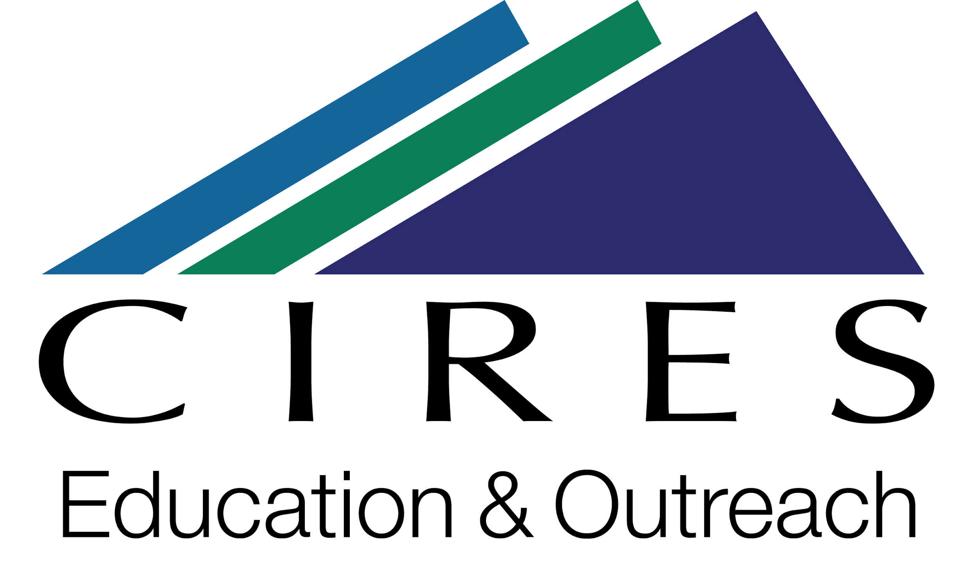

This lesson planning template was adapted for the NSF-sponsored MUSICA project by Katherine Ellins and Marlena Jones, using materials that were developed by CIRES Education & Outreach at the University of Colorado Boulder. CIRES teaching materials are available at https://cires.colorado.edu/outreach/resources/planning-templates.

The original template is licensed by CIRES under a Creative Commons Attribution 4.0 License http://creativecommons.org/licenses/by/4.0/

