Cranfield CO₂ Injection Site: Notes

Resource:
Lu, J., Kordi, M., Hovorka, S. D., Meckel, T.A., and C.A. Christopher, 2013, Reservoir characterization and complications for trapping mechanisms at Cranfield CO₂ injection site: International Journal of Greenhouse Gas Control, v. 18, p. 361-374.

*Measured core depths shown in these notes are not TVD.

FIELD OPERATIONS
- Field location: The Cranfield field is part of the Mississippi salt basin. The field is a salt-cored, simple dome structure located east of Natchez, Mississippi.

- History of field: The reservoir produced oil, gas condensate, and methane gas between 1944 and 1966. The field was pressure depleted and wells plugged and abandoned in 1965. The reservoir has been under CO₂-flooding for EOR since 2008 by Denbury Resources.

- Reservoir conditions: Reservoir temperature is 125 degrees C. Reservoir pressure was 32 MPa prior to CO₂ injection, and increased to 34 MPa when injection and production started. CO₂ is in supercritical state under reservoir conditions.

- CO₂ transportation: CO₂ is transported via a 160-km pipeline from Jackson Dome CO₂ field in Mississippi.

Trapping mechanisms CO₂ is trapped in a number of ways in the injection interval.

- Structural trapping: The four-way anticlinal closure of the injection ensures effective structural trapping of buoyant CO₂. A fault that intersects the reservoir appears to be sealing across and along it. Structural trapping is the most important trapping mechanism in the field.

- Residual trapping: Based on multiphase flow experiments, residual trapping could account for up to 8% of the rock volume swept by CO₂.

- Solubility trapping: TDS of 155,752 mg/L in brine limits solubility. But CO₂ flow paths in fluvial reservoirs are very complex and increase CO₂ - brine contact, thus, increasing dissolution.

- Mineral trapping: Capacity of mineral trapping is limited because the reservoir rocks contain only a trace amount of buffering minerals (carbonate and feldspar) which limits the supply of cations for converting CO₂ into carbonates.

The reservoir had received 3.54 million tons of CO₂ by February 2012 after CO₂-flooding was initiated in July 2008.

STRATIGRAPHY
The Tuscaloosa group (Upper Cretaceous) was deposited during a transgressive (shoreline moves landward) - regressive (shoreline moves seaward) cycle and is bounded by unconformities at the base and top of the formation that represent regional erosion surfaces.

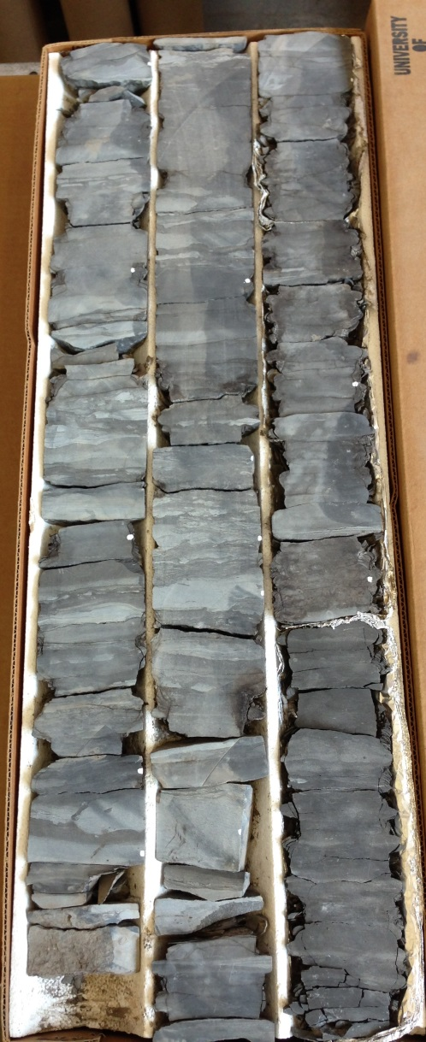
CONFINING INTERVAL
The confining interval is the middle Tuscaloosa marine shale (Upper Cretaceous) and is about 75m thick. Various facies found in the core show high capillary entry pressure and are able to retain a CO₂ column as much as 237m. Porosity and permeability for the interval are less than 4% and 0.0001 mD, respectively. The confining interval is sufficiently tight for retaining the injected CO₂ if its integrity is maintained.

Confining Unit (Seal)

230372148500
Franklin, MS
Denbury Onshore, LLC/BEG
CFU #31-F2
Q00601-A
Box: 11

10179-10187 ft = 3103-3105 m

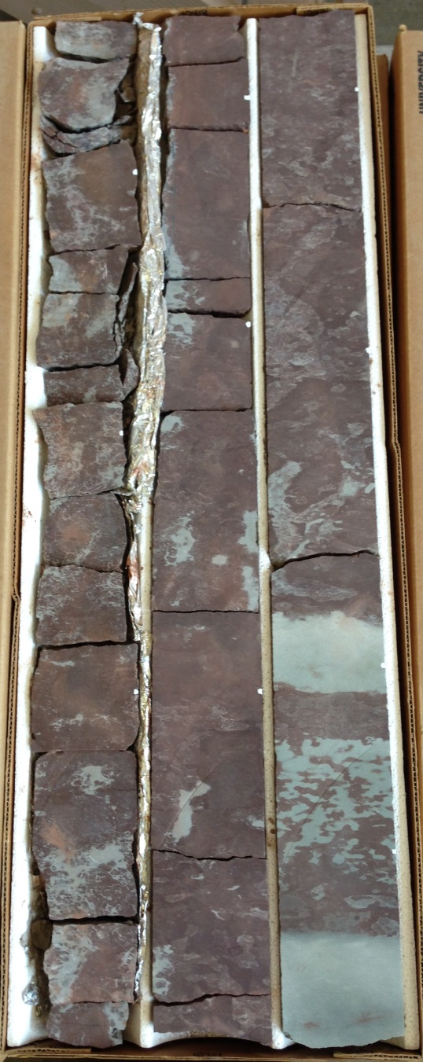
INJECTION ZONE

The Lower Tuscaloosa Formation represents a transgressive stage of the depositional cycle, with upward gradation from fluvial and deltaic to shelf sedimentation. The reservoir in the Upper Cretaceous Lower Tuscaloosa Formation consists of a 15-25-m thick package of fluvial sandstones and conglomerates deposited during multiple erosional and depositional episodes.

The injection zone is composed of crossbedded chert conglomerates, litharenite (lots of lithic fragments and quartz grains) sandstones, and muddy sandstones deposited during multiple episodes of channel incision and deposition.

The reservoir interval shows an overall fining upward succession, varying from a conglomeratic facies to a homogenous, coarse to medium sandstone with cross bedding and indistinct ripple laminations. Thin layers of mudstone and siltstone separating the sand bodies are identified in cores and logs. These thin, fine beds are associated with small channel deposition and change laterally over short distances. They do not act as field-wide flow barriers but their existence affects flow patterns and plume geometry.

Injection zone (Reservoir)

230372148500
Franklin, MS
Denbury Onshore, LLC/BEG
CFU #31-F2
Q00601-A
Box: 8

10415-10424 ft = 3174-3177 m

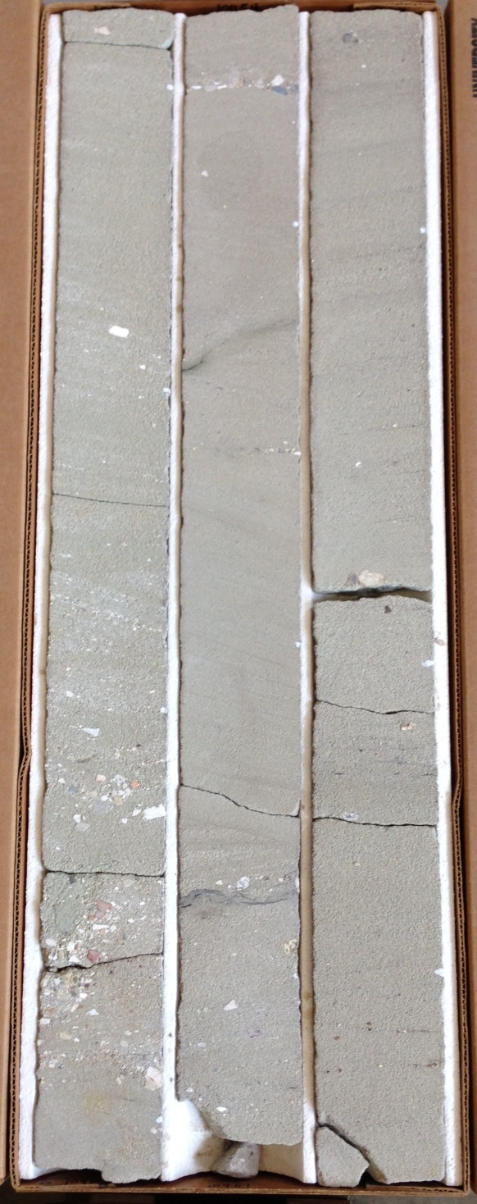
Injection zone (Reservoir)

230372148500
Franklin, MS
Denbury Onshore, LLC/BEG
CFU #31-F2
Q00601-A
Box: 4

10451-10460 ft = 3185-3188 m

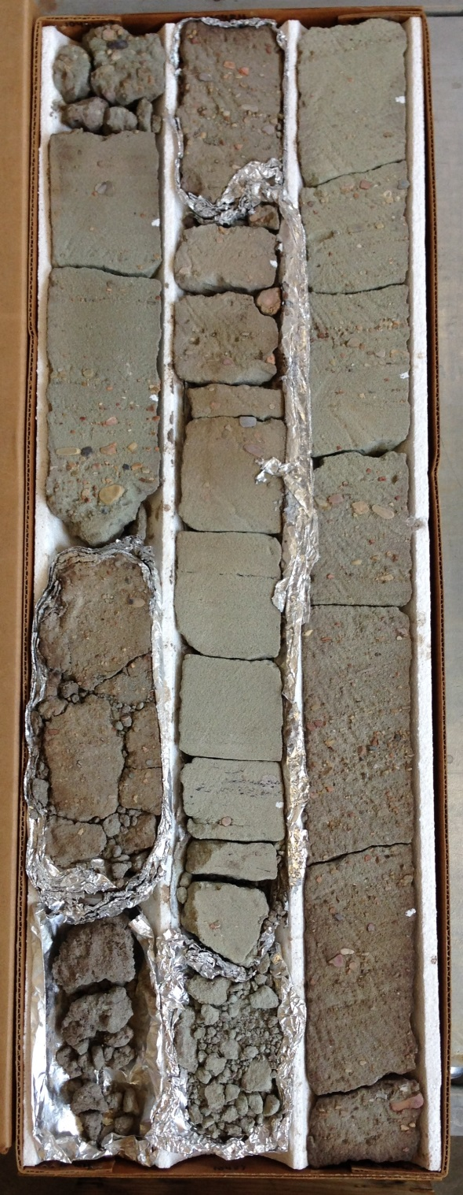
Injection zone (Reservoir)

230372148500
Franklin, MS
Denbury Onshore, LLC/BEG
CFU #31-F2
Q00601-A
Box: 2

10481-10490 ft = 3195-3197 m

DIAGENESIS
(changes in sediment brought about after its deposition but before its final lithification)

Some definitions:

- Detrital minerals, such as quartz, survive weathering and are transported to the depositional site as clasts.
- Authigenic minerals are generated where they are found (by precipitation or recrystallization).
- Effective porosity is the porosity that works to provide flow (effective is usually less than total porosity)

The chlorite story:
Chlorite is the most important authigenic mineral in the reservoir, giving the core a greenish appearance. Chlorite occurs from diagenesis as grain coating (rims), pore lining, pore filling and grain replacement.
- Chlorite grain coating is found to have a positive role in preserving porosity and permeability.
- Chlorite coats formed early in diagenesis, before precipitation of carbonate and quartz cements.
- Chlorite appears to have preserved porosity, where it formed thick grain coats and suppressed compaction and quartz cements.

The quartz overgrowth story:
Quartz overgrowth during diagenesis increases in the upper part of the reservoir where chlorite coats are not as abundant as in the lower part.

The dissolution story:
Creation of secondary porosity generally increases effective porosity.
- Secondary porosity is formed mainly by dissolution of rock fragments and matrix during diagenesis.
- Dissolution of rock fragments and minerals formed a significant fraction of total porosity (34%).

