What’s the Value of Value-Based Healthcare?
Value-Based Healthcare is…  - Paying for Quality rather than Quantity of Care  - Moving away from fee-for-service model which incentivizes more care rather than preventive/effective/well-coordinated care  - Cost of care vs. Outcomes (lowering cost & improving outcomes are not always mutually exclusive!) | Value-Based Healthcare isn’t…  - Rationing care or a gate-keeper model  - One-size fits all – looks different for different markets, communities, payors  - A magic bullet, panacea or guaranteed success
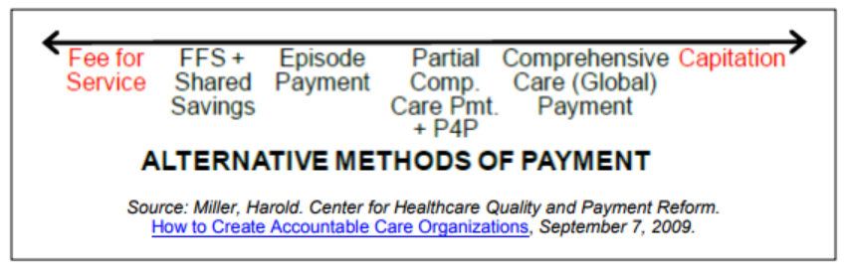

Value-Based Healthcare assumes:
- Reliable data, metrics & exchange of data (if you’re paying based on outcomes, you need to be able to measure outcomes)  - Coverage (i.e. insurance) & access (i.e. accessible providers)  - Changes historic funding streams & who takes on risk  - Some high-cost care is preventable (e.g. non-emergent ER visits) | - Coordinated, whole-person care ensuring continuity of care (which includes removing silos, eliminating duplication of tests, team-based approach to care delivery)  - Some degree of accountability from patients, providers & system, price transparency & awareness of cost, & health literacy/navigation  - Multi-payor initiatives are needed to see real change!

RESOURCES

Value 101:
- The Structure & Cost of US Health Care: Crash Course Sociology: youtube.com/watch?v=KriEIJ0ubh0
- What is Value-Based Healthcare? catalyst.nejm.org/what-is-value-based-healthcare

@ Dell Medical School
Value Institute for Health and Care: dellmed.utexas.edu/value-institute-for-health-and-care
- Q&A with Professor Elizabeth Teisberg: Rethinking Health Care Value: blog.dellmedschool.utexas.edu/2016/06/21/qa-professor-elizabeth-teisberg-rethinking-health-care-value/
- Elizabeth Teisberg | High Value Health Care: Achieving Ever-Better Outcomes: youtube.com/watch?v=HyGNUXfKIbk
- Value-Based Care Learning Modules: vbhc.dellmed.utexas.edu

