PSTI Lesson and/or Unit Planning Template Part 1
Teacher’s Name: Kathy

Earth & Space Science: 1.C, 2.E, 2.F, 2.H, 3.D, 3.F, 9.C, 10.B, 12.B, 12.D

PART 1a.
Grade and Subject | Instructional Time Required (250 Minutes)  Earth and Space Science | 5 class periods (50 minutes each)
Unit or Lesson Title (Topic) | Energy Resources (Hydrocarbons): In Pursuit of a Safe Well
Anchoring Phenomenon (a) | Phenomenon (a). Please list overarching or “Big Ideas”  - Human’s Depend on Earth for Resources  - Fossil fuels, such as oil and natural gas, make up an important energy resource. Their abundance of makes them the dominant source of for the near future.  - Earth scientists seek to understand the occurrence and environmental impacts of our use of fossil fuels (Relevance)  - The interacting components of Earth's system change by both natural and human-influenced processes.  - Proper stewardship of Earth will prevent unnecessary degradation and destruction of Earth's subsystems and diminish detrimental impacts to individuals and society (Relevance)  Driving Questions. Make a short list of questions that promote deep understanding, higher order thinking, and inquiry and which spark discussion and debate, and raise further questions.  - What are hydrocarbons? How and where do they form?  - What is a well?  - How do geologists determine where to place a well?  - How can the extraction of hydrocarbon resources potentially damage Earth's system.  - What are the geologic and engineering factors that must be considered to safely construct a well that will not be prone to leaks or contamination?  - During drilling operations and energy production, what well control procedures may be instituted to reduce the risk of a blowout?  Curriculum Spark(s). What will you do, show or say to pique learner’ interest?  I will show students the 12-minute You Tube Video, Deepwater Horizon Blowout Animation, available in Energy Excursions, Macondo Well Case Study, What Went Wrong?  The video examines the multiple failures that led to the Deepwater Horizon Blowout. It describes how the blowout preventer that was intended to shut off the flow of high-pressure oil and gas from the Macondo well in the Gulf of Mexico during the disaster on the Deepwater Horizon drilling rig on April 20, 2010, failed to seal the well because drill pipe buckled for reasons the offshore drilling industry remains largely unaware of.
Learning Goals/ Lesson Topics | List lesson concepts related to grade level and state standards that support student learning goals. For Texas teachers these are the TEKS.  Earth and Space Science (12.B, 12.D)  (12) Solid Earth. The student knows that Earth contains energy… resources and that use of these resources impacts Earth's subsystems. The student is expected to:  (B) describe the formation of fossil fuels, including petroleum...  (D) analyze the economics of resources from discovery to disposal, including technological advances, resource type, concentration, and location, … and environmental costs.
Grade level Performance Expectations (PEs)  and  EVIDENCE of learning. | Use the TEKS as your primary guide for how you state your performance expectation(s).  PE: Students who complete this unit will be able to organize information to communicate the various considerations for drilling a well for oil and gas production, including how to the mitigate risks associated with drilling a well and resource extraction.  This includes being able to  - Describe the formation and occurrence of hydrocarbons  - Identify subsurface containment risks posed throughout construction and production of a wellbore and classify well containment approaches  - Analyze the outcomes of the Deepwater Horizon Blowout. Discuss the environmental, economic and societal costs  - Discuss technological advances, and legal and ethical remedies put in place after the accident.  Note: You may also refer to the grade level NGSS Performance Expectations (PEs) because they have informed the most recent revision of the science TEKS.  --------------------------------------------------------------------------  Please describe the “evidence” that you will look for to determine if your students have mastered content and skills contained in the lesson. List or describe the criteria that you will use to assess if your students have met your performance expectation(s).  Examples of observable features of student performance that will tell me they have met performance expectation(s).  Identifying relationships:  - Students recognize the relationships between the changes in one part and changes in another part of the Earth system  - Students identify and describe the relationships between components of a safe well  - Students identify how specific technologies and engineering designs can help prevent unnecessary degradation and destruction of Earth's subsystems and diminish detrimental impacts to individuals and society (Relevance)  Evidence  - Students provide evidence of the dependence of human populations on technological systems to acquire natural resources for our energy use.  - Students identify evidence for the design solutions, including the cost of safely extracting or developing hydrocarbon energy reserves  Organizing data:  - Students can organize information to describe the impacts of the Deepwater Horizon Blowout at Earth’s surface.  Reasoning/synthesis:  - Using the case study of the Deepwater Horizon Blowout, students describe that a decision on the “best” solution may change over time as engineers and scientists work to increase the benefits of design solutions while decreasing costs and risks.
PART 1b.

Unpack the components of the Performance Expectations that you choose using the TEKS in the table below.
1.C, 2.E, 3.E, 12.D
Skills  Evaluate  Describe  Analyze  Identify  Classify  Reason  Communicate | State standards (Concepts)  The student is expected to:  (A) evaluate how the use of energy, water, mineral, and rock resources affects Earth's subsystems;  (B) describe the formation of fossil fuels, including petroleum and natural gas;  (D) analyze the economics of resources from discovery to disposal, including technological advances, resource type, concentration and location, waste disposal and recycling, and environmental costs; | Cross-cutting Concepts (CCCs)  Stability and change  Cause and effect  Systems  Energy  Relevance

PART 1c.
Teacher Preparation
Student Misconceptions  (Potential student ideas that are problematic when engaging in the lesson)  Oil is mostly dinosaur bones.  Energy from hydrocarbons is bad  The world will run out of oil very soon.  Modern society does not need hydrocarbons for energy and industrial processes  Hydrocarbons don’t contribute to greenhouse gas emissions and pollution. | Scientific Terminology  Fossil Fuels  Hydrocarbons  M Kerogen  Well  Wellbore  Blowout Preventer  Tectonic activity  Meromictic  Source rock | Reservoir rock  Viscosity  Density  Hydrostatic pressure  Mus  Bentonite  Drlling rig
Supporting Information
References  (Links to cite sources of data, images, websites, etc.)  PSTI, Energy Excursions, In Pursuit of the Safe Well, available at  https://courses.energyexcursions.com/courses/in-pursuit-of-the-safe-well/lessons/macondo-well-case-study/topic/basics-of-the-macondo-prospect/ | Background Reading/ Viewing  (For teachers and possibly students as well)  PSTI, Energy Excursions, In Pursuit of the Safe Well, available online at https://energyexcursions.com.  Petroleum Extension Service (2011), Fundamentals of Petroleum, The University of Texas Press, 679 pp.

Resources/ References (Please cite your resources properly. All websites must be properly cited. Examples of how to cite your sources)

- BBC Four: Ancient Apocalypse: The Maya Collapse, https://www.youtube.com/watch?v=fuFL5ETw6oQ
- Brenner, M., Rosenmeier, M., Hodell, D., & Curtis, J. (2002). PALEOLIMNOLOGY OF THE MAYA LOWLANDS: Long–term perspectives on interactions among climate, environment, and humans. Ancient Mesoamerica, 13(1), 141-157. Retrieved November 6, 2020, from http://www.jstor.org/stable/26308050
- Gill, Richardson (2018). The Great Maya Droughts: Water, Life, and Death, University of New Mexico Press.
- Hodell, D., Curtis, J. & Brenner, M. (1995). Possible role of climate in the collapse of Classic Maya civilization. Nature 375, 391–394. https://doi.org/10.1038/375391a0
- Marx, W., Housnchild, R. and Bornmann, L. (2017). The Role of Climate in the Collapse of the Maya Civilization: A Bibliometric Analysis of the Scientific Discourse, Climate 5(4):88. DOI: 10.3390/cli5040088

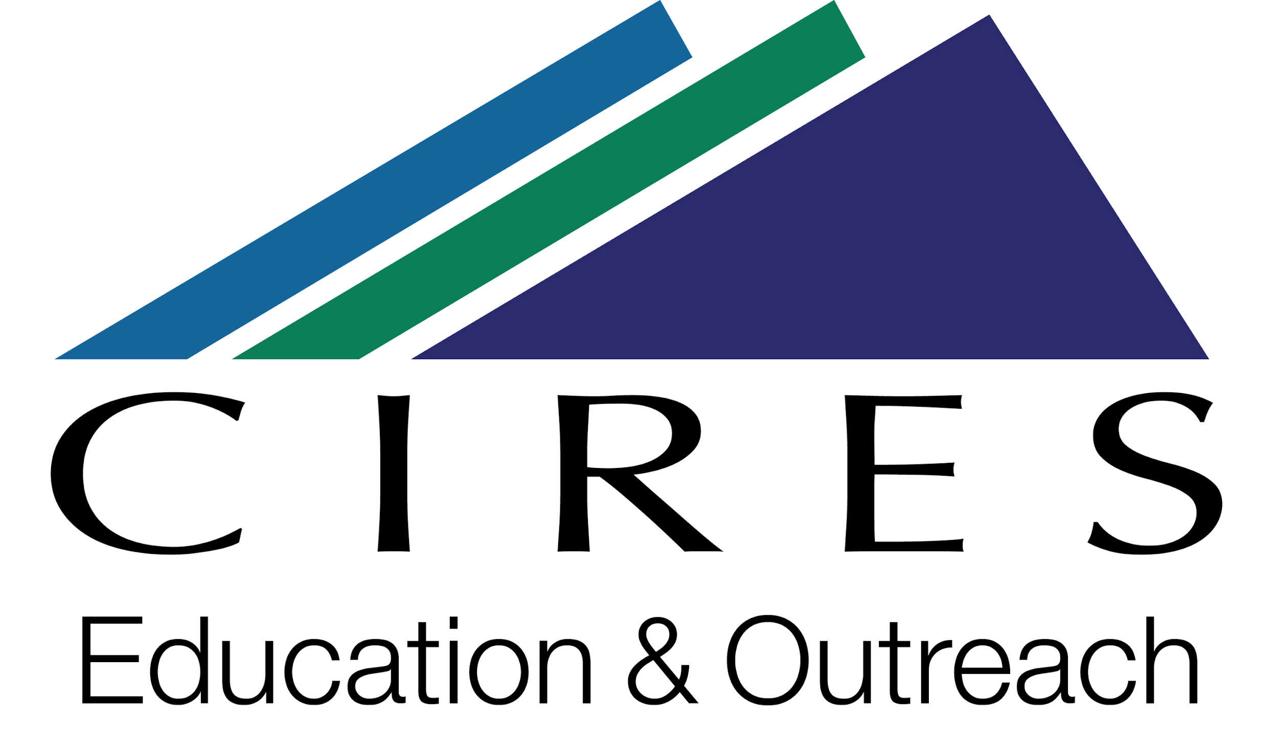

This lesson planning template was adapted for the PGE Hildebrand PSTI project by Katherine Ellins, using materials that were developed by CIRES Education & Outreach at the University of Colorado Boulder. CIRES teaching materials are available at https://cires.colorado.edu/outreach/resources/planning-templates.

The original template is licensed by CIRES under a Creative Commons Attribution 4.0 License http://creativecommons.org/licenses/by/4.0/

RESOURCES FOR TEACHERS

Phenomena

Phenomenon based learning starts from the shared observation of holistic, genuine real-world phenomena in the learning community. The observation is not limited to one single point of view; the phenomena are instead studied holistically from different points of view, crossing the boundaries between subjects naturally and integrating different subjects and themes. As you go through the PSTI, you will see the many ways in which this happens.

See more at http://www.phenomenaleducation.info/phenomenon-based-learning.html

This brief resource about phenomena was developed for educators, and describes how phenomena can be used in NGSS classrooms to drive teaching and learning. As Texas teachers you will be focused on the TEKS. However, this resource may help you in your lesson planning activities. The three-minute video interview below with Brian Reiser introduces phenomena and is especially helpful in describing the value using phenomena in your teaching.

Performance Expectations

Use the TEKS as your primary guide for how you state your performance expectation(s).
You may also refer to the grade level NGSS Performance Expectations (PEs) that support student learning goals for additional guidance since these have been used to inform the revised science TEKS. For the NGSS, the PE color coding reflects its 3-dimensional learning components.

Evidence of Learning

Note: If you need guidance on “evidence” of content and skills mastery you can search the NGSS Evidence Statements. These evidence statements will offer examples of what students should know and be able to do to satisfy an NGSS Performance Expectation (PE). You can follow the examples as you develop your own criteria for the evidence you are looking for after students complete the lessons you develop.

